November 2023

Dear Customer,

I am writing to let you know that we plan to work in your local area. This work will be for patching repairs to the Highway **between Rowley and Brockton**.

**Where is the work?**

We will be undertaking this work with a road closure between Rowley and Hampton Beech as shown on the map below. Please note access/egress for properties **within** **the closure will be allowed** **using the diversion route as per map.**

**When will this work take place?**

From **Wednesday 29 November and Friday 01 December** there will be a **24hr road closure** we will be working between **9am and 4pm**.

Please note that all our planned roadworks are subject to change due to weather conditions or unforeseen circumstances. Any changes will be displayed on the yellow advanced warning signs and <https://one.network/>

**How will this affect traffic?**

Signs will be erected on the road before starting the work and the work will be completed as quickly as possible. A signed diversion route will be in place.

**Will there be access to my property/business?**

Yes, if you are looking to access your property or business within the closure, you may drive via the diversion route depending on which side you live of the diagram below.

**Please check additional diagram below showing point of NO ACCESS to vehicles**

During the road closure, access to properties will be restricted to:

* Essential highway personnel
* Residents who live and reside within the road closure
* Businesses located within the closure (if applicable)
* Pedestrians, dismounted cyclists and equestrians
* Emergency service vehicles

**Where is the work?**

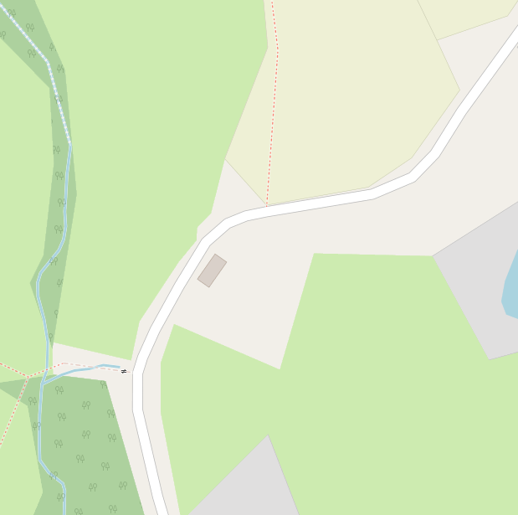

Road closed here –

no access for any vehicles

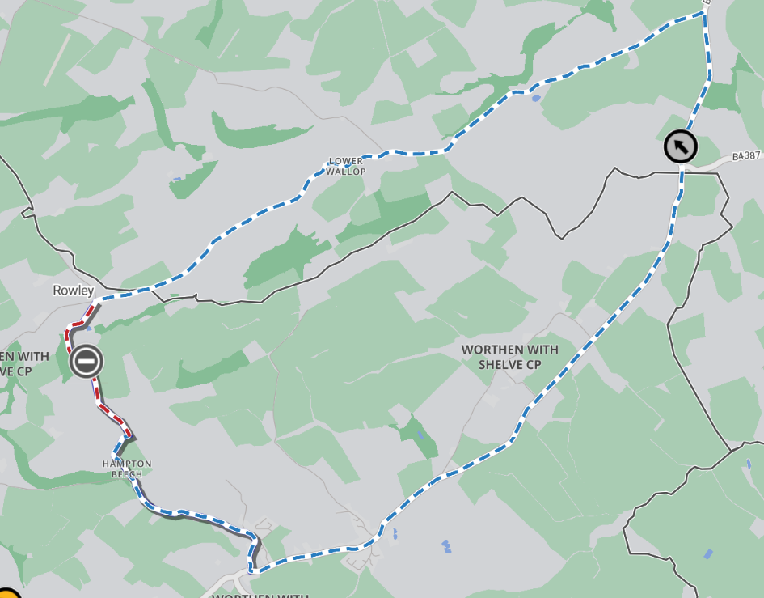

Closure

Diversion

**How can you help us?**

It would be appreciated if you could ensure vehicles are not parked on the road during the day whilst the work is in progress. Please be mindful that we can only provide access for properties/businesses within the work area. Should this cause any problems or concerns then please do not hesitate to call the number below or speak to our team on-site.

**Find out more**

Should you have any queries or wish to discuss any of the above please do not hesitate to contact Shropshire Council’s Highways Customer Services Centre on 0345 6789006. Full details of work to be carried out in your area can be found on <https://one.network>

Kind regards

**Shropshire Highways**